Information about your Approach Social Work assessment centre
Congratulations on being invited to attend an assessment centre. This is the final stage in the selection process and you’ve done really well to get this far. The information contained in this document is intended to give you information about how our virtual assessment centres will operate.

Where and how will my assessment centre take place?
Assessment centres are run virtually, using an assessment centre platform called TopScore. This means you can complete your assessment centre without needing to travel.
With assessment centres being virtual, every effort has been made to ensure consistency and robustness in the assessment process. Our assessors have been trained to assess virtually and we have adapted our exercises to fit this environment.

Technical requirements
Due to the virtual nature of the assessment centres, access to a laptop/PC with a strong internet connection, camera, and microphone for the duration of the assessment centre is a fixed requirement. Specifically, if you do not have access to a stable WiFi connection, you should carefully consider how you can meet this prerequisite to decrease the chance of encountering technical issues while completing your assessment activities.
Please also ensure that you are situated in an area with limited distractions and background noise for the duration of your assessment centre. TopScore has provided guidance on which browsers and devices are most compatible with the platform:
- Use a Windows/Linux laptop/PC with Chrome, Firefox, Opera, Vivaldi, or Edge web browser
- OR use a Mac with Chrome, Firefox, or Safari web browser
- OR android tablet with Chrome or Firefox web browser
- Or iPad with Safari web browser only
- Device must have audio and camera capability
- Must have a stable internet connection
- Phones should be avoided
It is strongly recommended that you use the latest version of your selected browser and Chrome where possible as it is usually the most reliable. If you are unable to meet any of these requirements, please do not sign up to an assessment centre and contact the recruitment team via our website for guidance.

Receiving your TopScore login details
The day before your assessment centre you will receive login details for your candidate TopScore account which should come via email before 5pm. This will allow you to check you are able to log in before the start of your first assessment centre activity. If you have not received this email by 5pm on the day before, please contact the recruitment team via our website for help.

Performing a compatibility test
When you receive your login details for TopScore please use the provided hyperlink to complete a device compatibility test. This test will confirm whether TopScore is able to recognise your camera and microphone, and if your web browser is compatible with the platform. You will also be able to complete the compatibility test from your Welcome Brief page when you first log in to TopScore, as shown in the screenshot below.
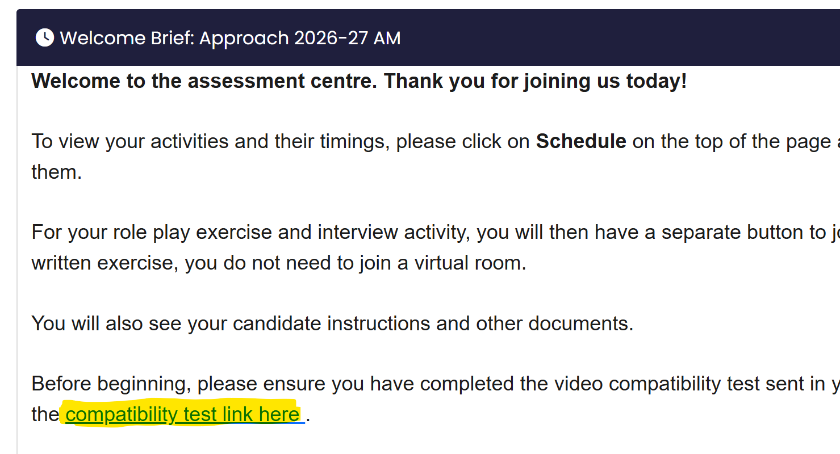

Using TopScore

Logging into your candidate account
Please log in to TopScore using the link in the email received the day before your assessment centre. Your login details will be your email address, and the password provided in the email.

Viewing your assessment schedule for the day
Please click on My Schedule at the top right-hand side of your screen to see and enter your activities for the day, as in the screenshot below.
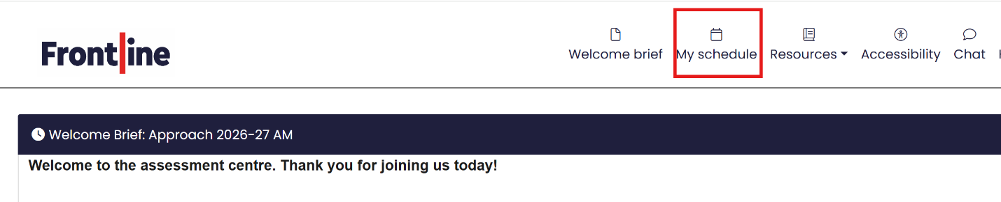

Joining activities and virtual rooms
On your schedule, you will find your activities listed in order. Please click on the black button as shown below to enter your activities. Depending on the activity, the text might say Show Brief and Join Virtual Room or Show Brief. Please see the screenshot below for an example.
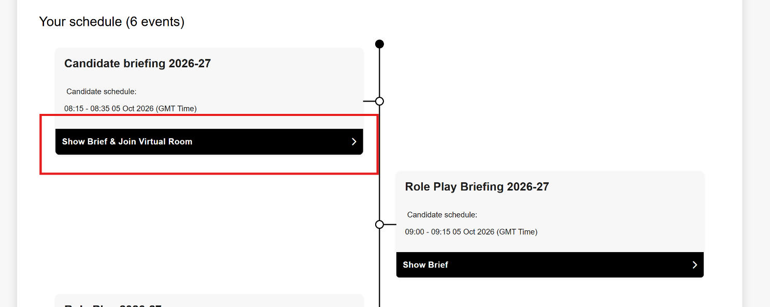

This will take you to the exercise brief where you can then join the virtual assessment room by clicking Join virtual meeting room, as in the screenshot below.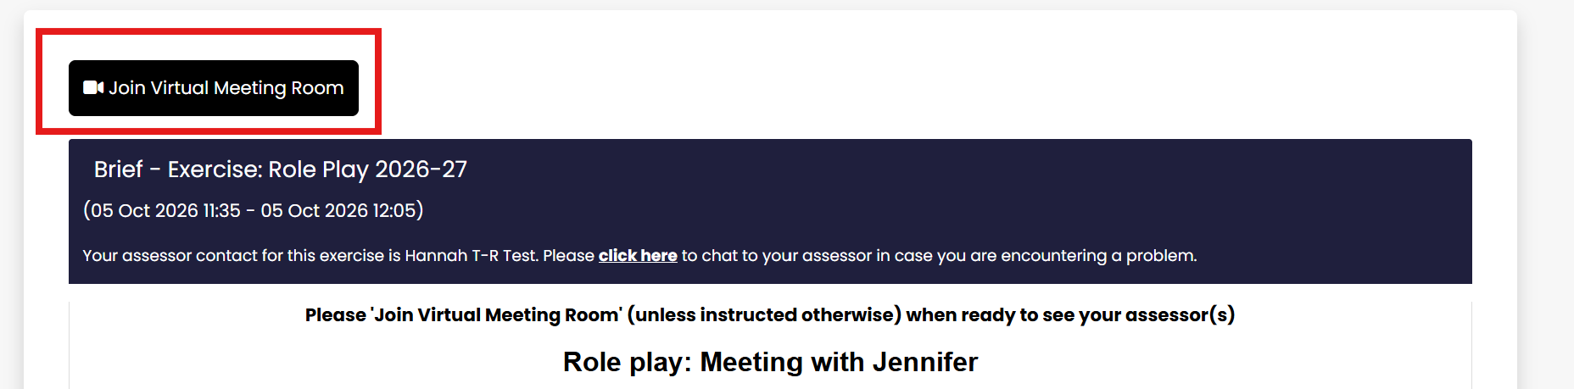

Managing technical issues
If you are unable to connect to a virtual meeting room during the assessment centre please try the following to troubleshoot your issue:
- Leave and re-join the virtual meeting room
- Check your internet connection (you will see a red warning message if TopScore detects a loss of internet signal) – if you have an unstable connection, you can:
  - Try moving to another location in your home that is closer to your internet router.
  - Enable 4G/5G hotspot if the main Wi-Fi is not working
  - Turn off your camera to use less bandwidth
  - Use an ethernet cable as this can improve your connection
  - Try a different web browser
- Check you are not connected to another video call and close any applications or windows that are not being used.
- Try using another device – ideally a laptop or PC, but tablets can be used too.
- Click the settings icon and make sure you have selected the correct microphone and camera options
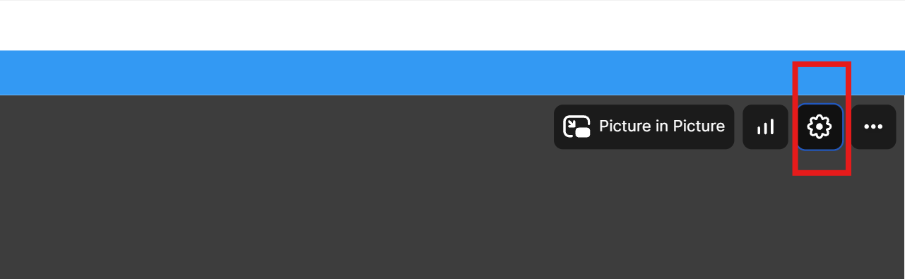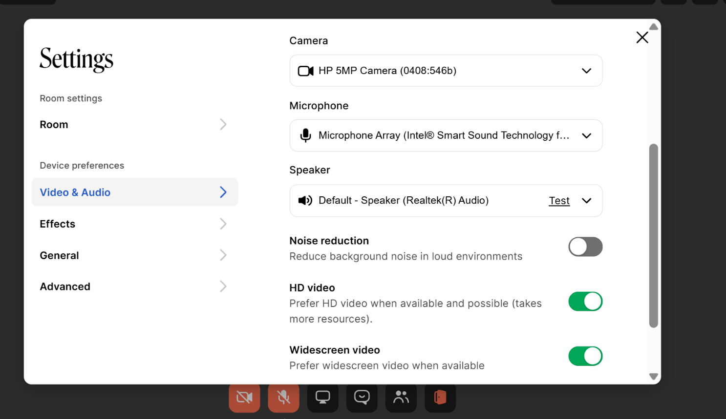
Completing your written exercise
For your written exercise, you will be required to produce typed output. We recommend you use a PC or laptop for this activity. To start this activity, please press the Start Assessment button as seen in the screenshot below.
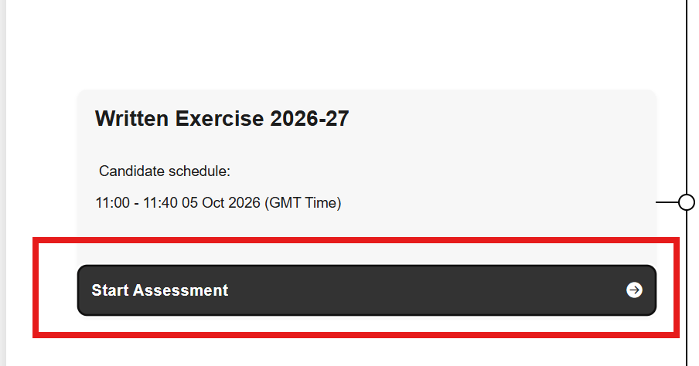
Once in the activity, you will find a tab on the left-hand side for your Candidate Brief, which will include instructions on the activity and attached documents, and a tab called ‘Write your response here’. You will need to navigate to ‘Write your response here’ to input your response.
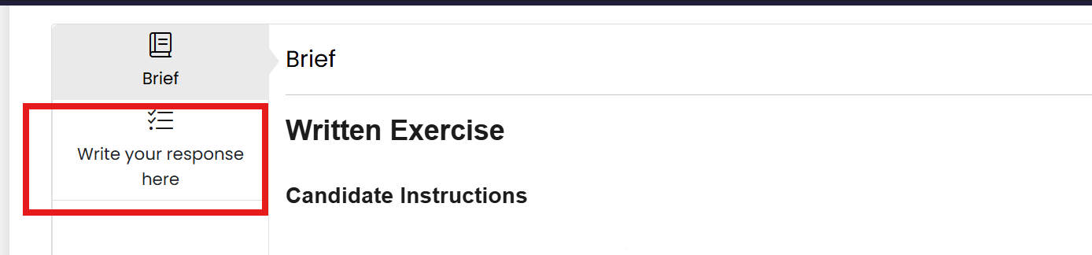
This will show a text box similar to a Microsoft Word document, which allows different formatting as necessary (e.g. bold, italic, underline, etc). At the end of the written exercise, there will be a 3-minute grace period before the session expires. Please remember to the click Save button as your final action before you complete your exercise and close the window.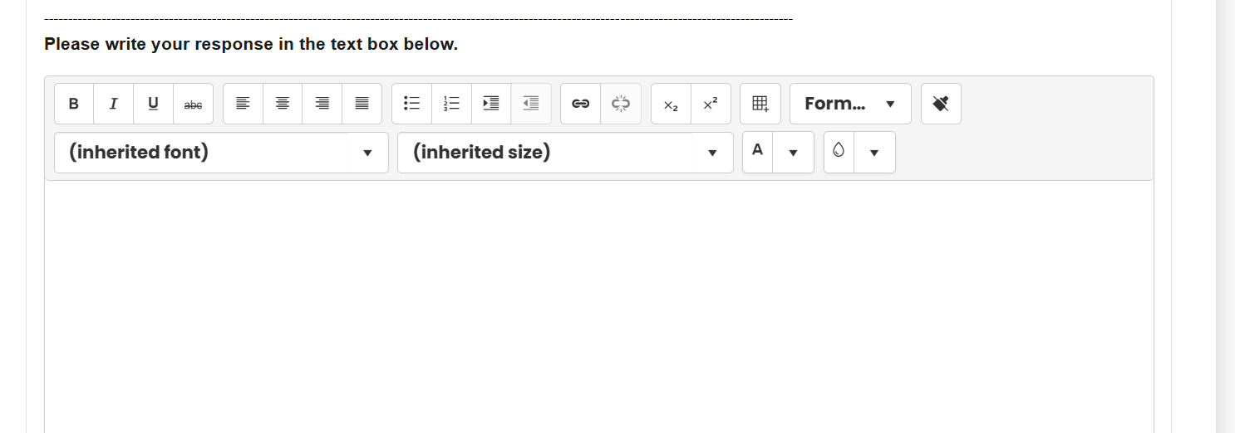

Using instant chat
After logging into TopScore, you will be able to access the platform’s chat function for the duration of your assessment centre. Please use this function to communicate with an admin when you need assistance.
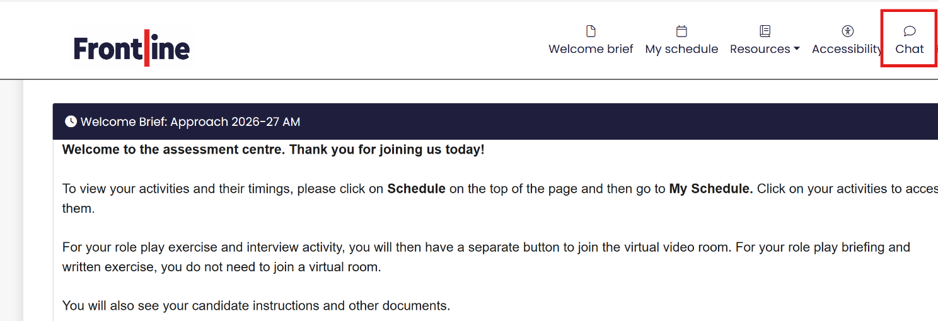

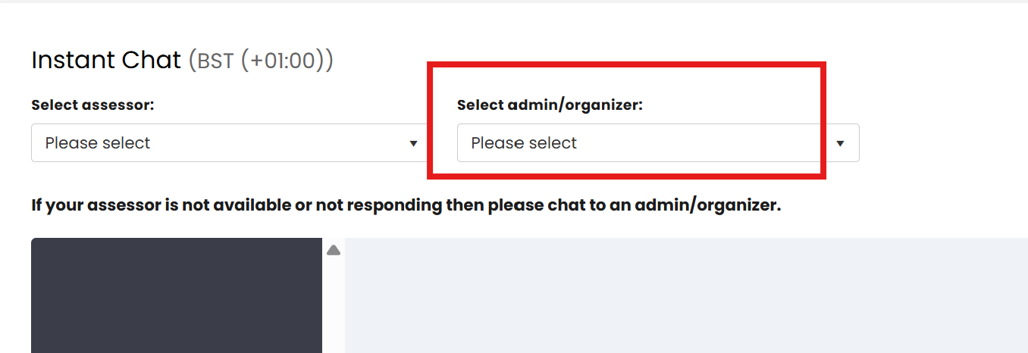

Accessibility
TopScore’s accessibility toolbar includes added accessibility tools including text-to-speech, reading supports, a text magnifier and different styling tools. You can access the accessibility toolbar by clicking on Accessibility at the top right-hand side, as in the screenshot below.
The toolbar will appear at the top of your screen, as shown below.
